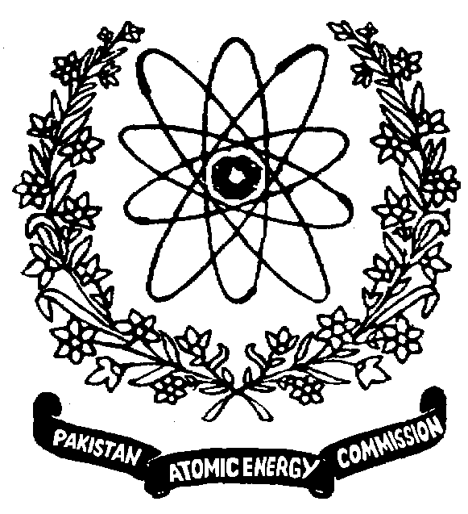 | Nuclear Institute for Food & Agriculture (NIFA)  P. O. Box 446, Tarnab, Peshawar, KP, Pakistan

Subject: APPROVAL OF INTERNSHIP
Student information
Name of Student: ________________________ | Father name: ____________________________
Degree Program: ________________________ | Registration No.: _________________________
Session: ________________________ | Department: _____________________________
Name of University: ________________________________________________________________
Name of Division in NIFA where internship will be conducted:______________________________
Area of research/experience to be gained: ______________________________________________
________________________________________________________________________________
________________________________________________________________________________
Agreement for Internship work at NIFA, Peshawar:
We, student and supervisors (from university and NIFA) are agreed that:
- Name of supervisor from NIFA will be included in all the publications from research work conducted at NIFA at appropriate place in author’s list.
- Student will be responsible for the management of his research work and no financial/human resource assistance will be provided.
- Internship period will be from minimum 3 months to maximum 6 months.
- NIFA Supervisor will be responsible for student’s regular attendance and authenticity of duration of internship for issuance of certificate.
- Submission of the internship report in soft copy is compulsory for certificate issuance
- Request for issuance of certificate should be raised within the one month of completion of internship; afterwards the request will not be entertained.

___________________________  Name and signature of student | ________________________________________  Name, signature and seal of supervisor at University. Supervisor Cell # _______________

________________________________________  Name and signature of NIFA supervisor | _______________________________________  Name and signature of Head of Division

Incharge Student Affairs: _________________________________

Director NIFA: __________________________________________

Incharge Student Affairs: _________________________________

